NAME________________________LAB MEETING DAY/TIME___________________

Lab 4, Sedimentary Stratigraphy

Lab 4 will cover Exercises 5 and 6 in your lab manual. Your TA will go over each exercise prior to you working through the questions; this will help orient you to the main topics covered in this lab – lithostratigraphy, biostratigraphy, and chronostratigraphy.

# **Exercise 5 – Part A**

**Complete questions 1 and 2 on the right side of the figure below. Complete question 3 on the left side of the figure.**

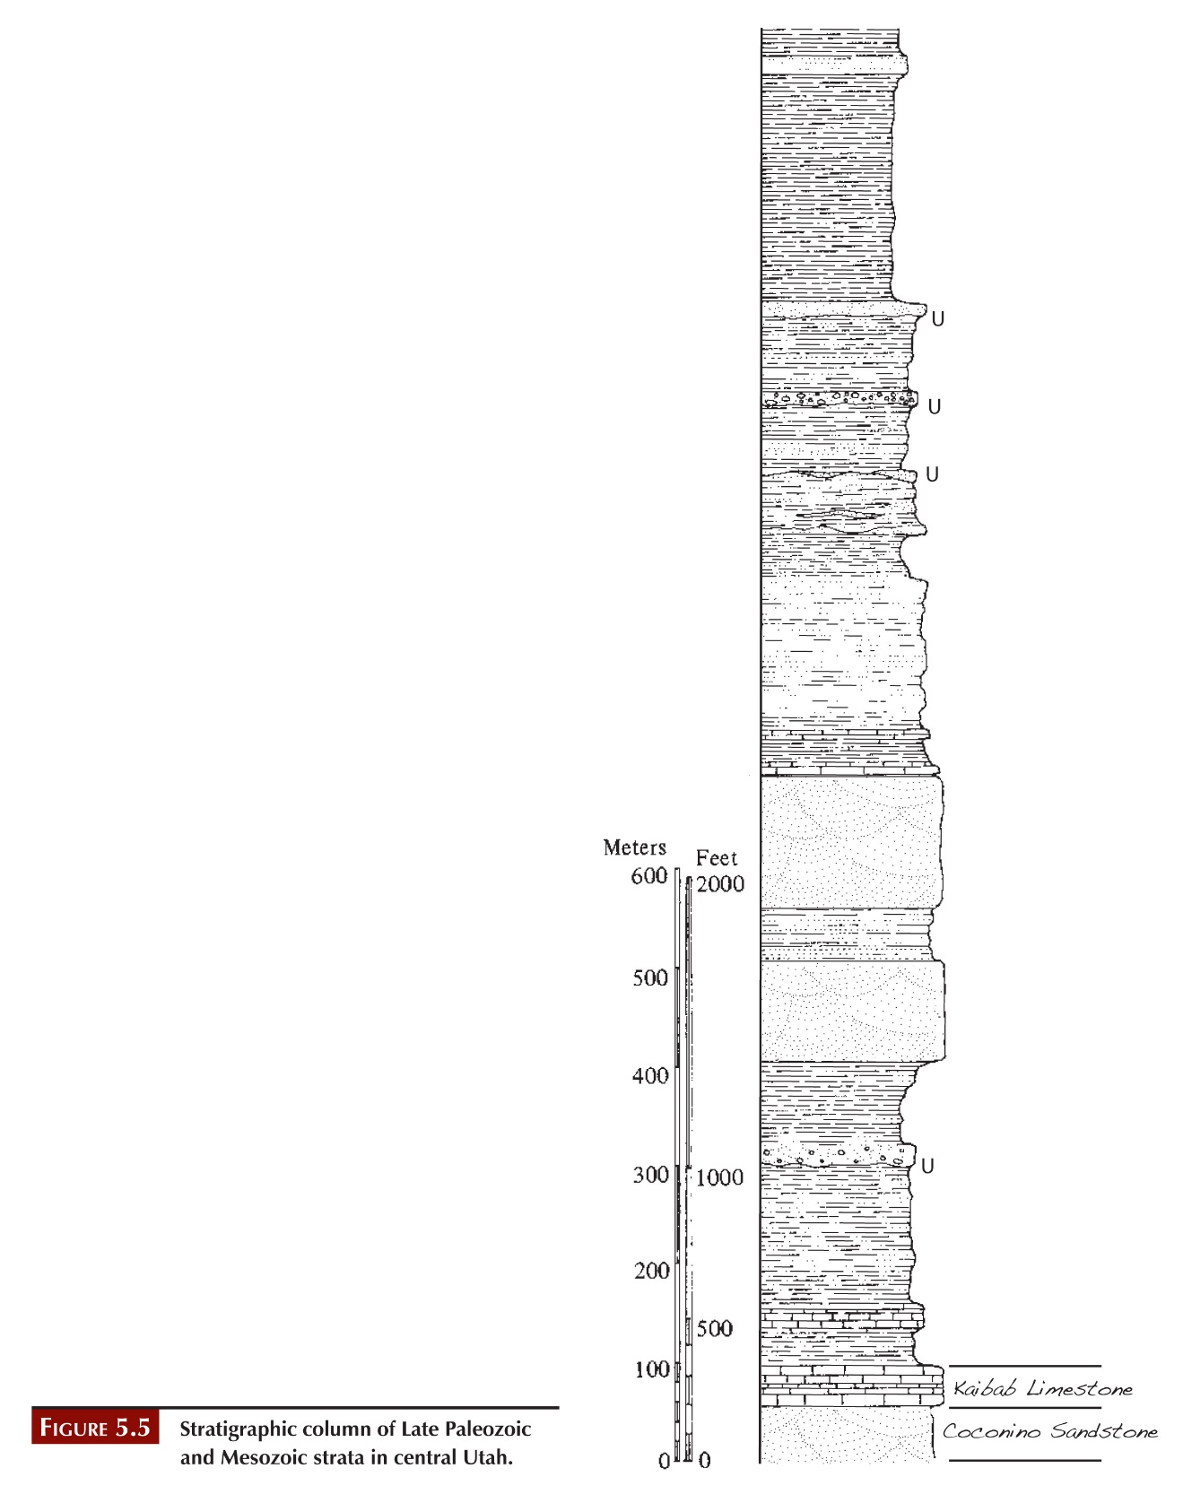

# **Exercise 5 – Part B**

**Using the directions on page 65 of the lab manual, complete the figure below.**

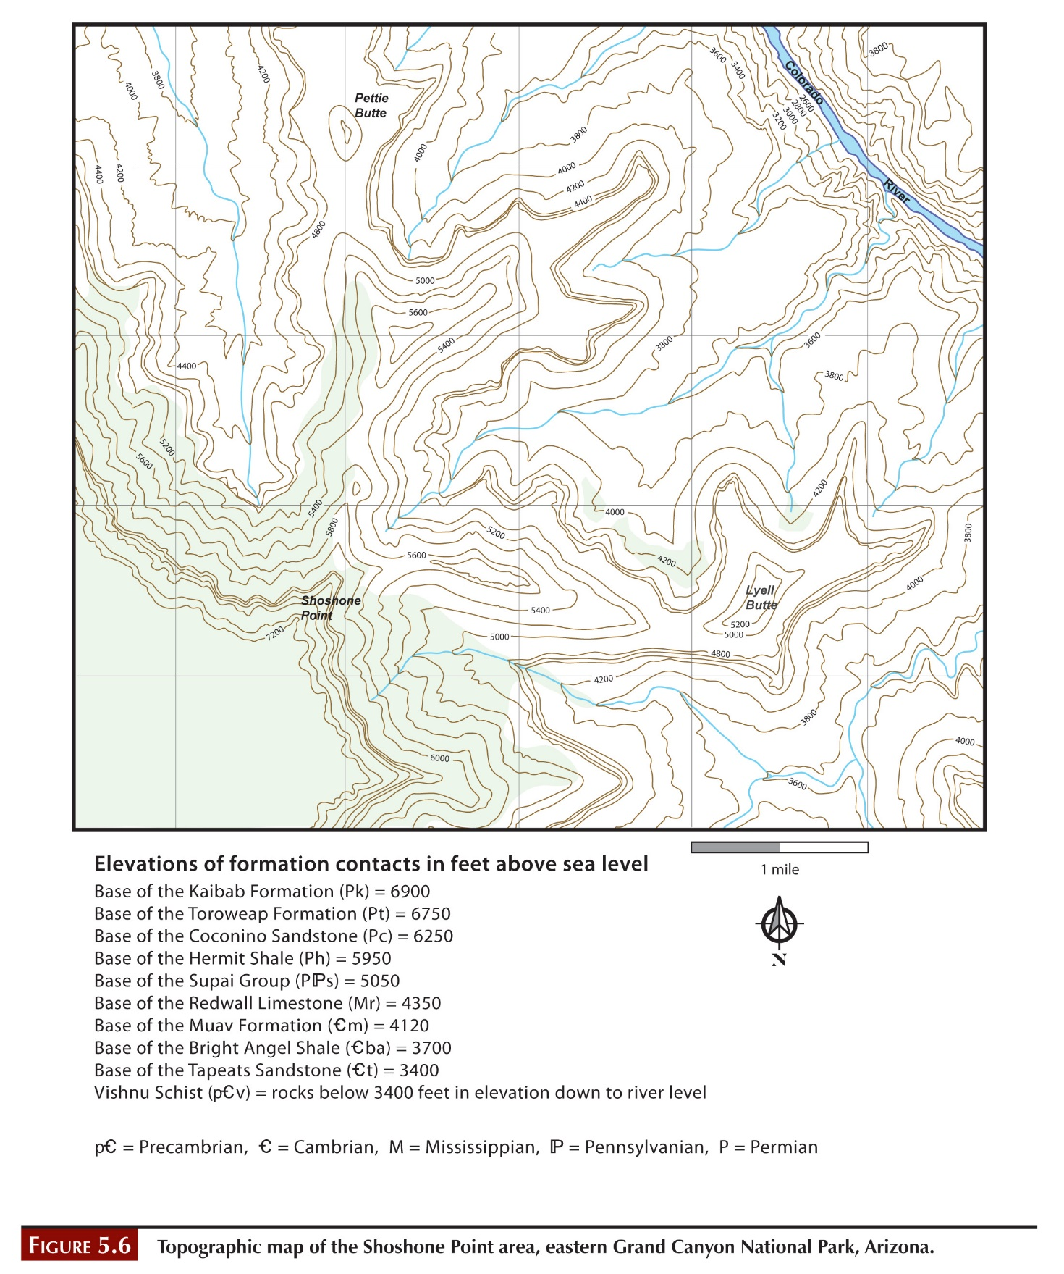

**Then, answer the question given on page 65: What is the relationship between geological contact lines and topographic contour lines when the formations are oriented horizontally?**

# **Exercise 5 – Part c**

**Complete questions 1, 2, 3, and 4 using this figure.**

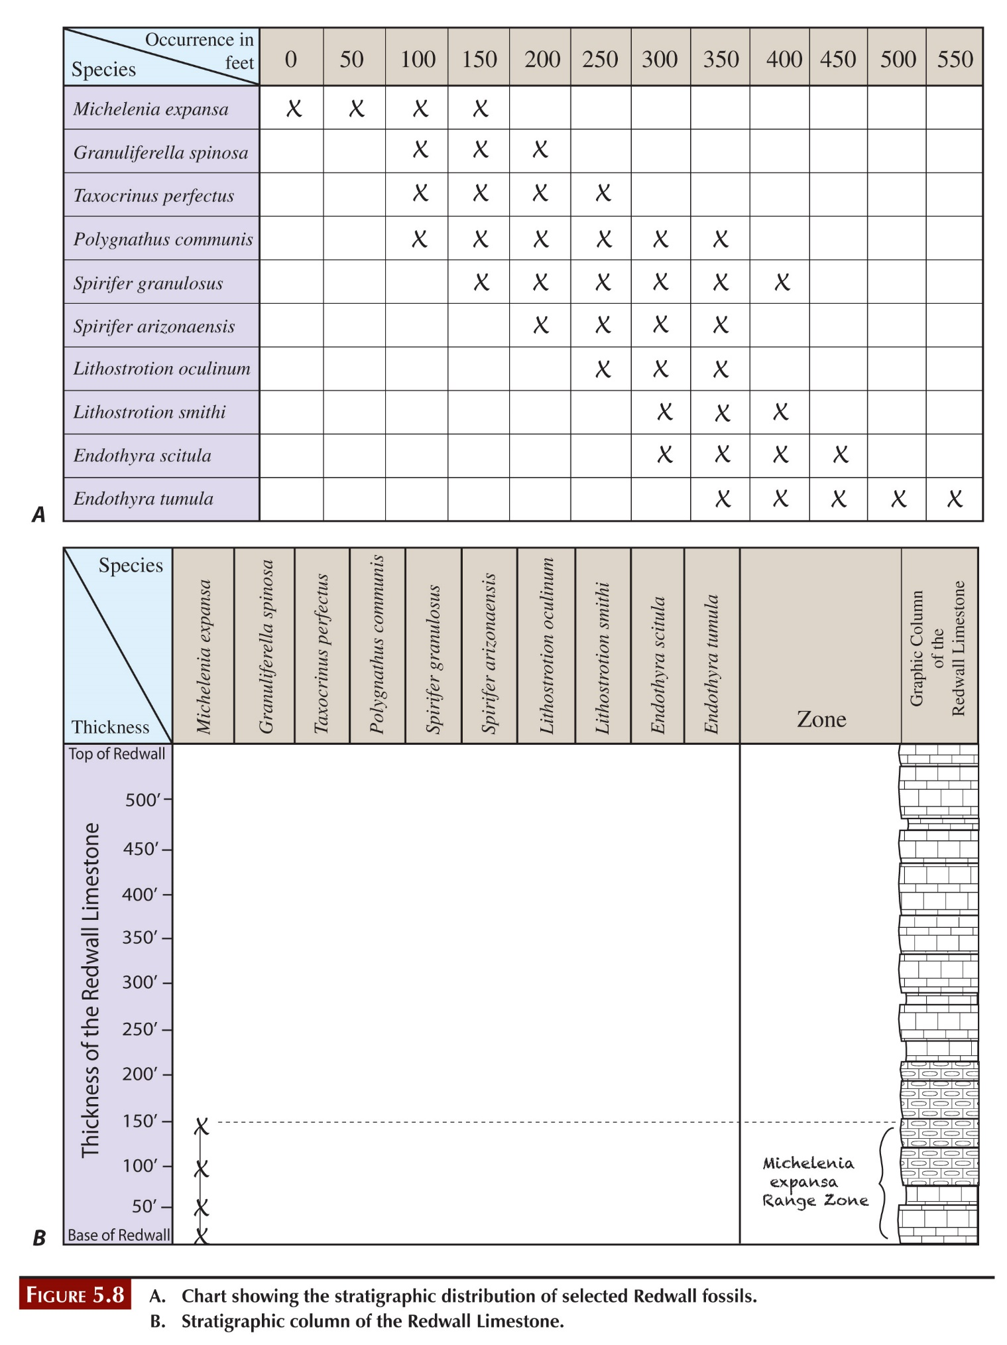

**5.**

**6.**

**7.**

# **YOu May skip Exercise 5 – Part D**

**Go on to the next page of this worksheet.**

# **Exercise 5 – Part E**

**Complete the figure below using the directions on page 75**

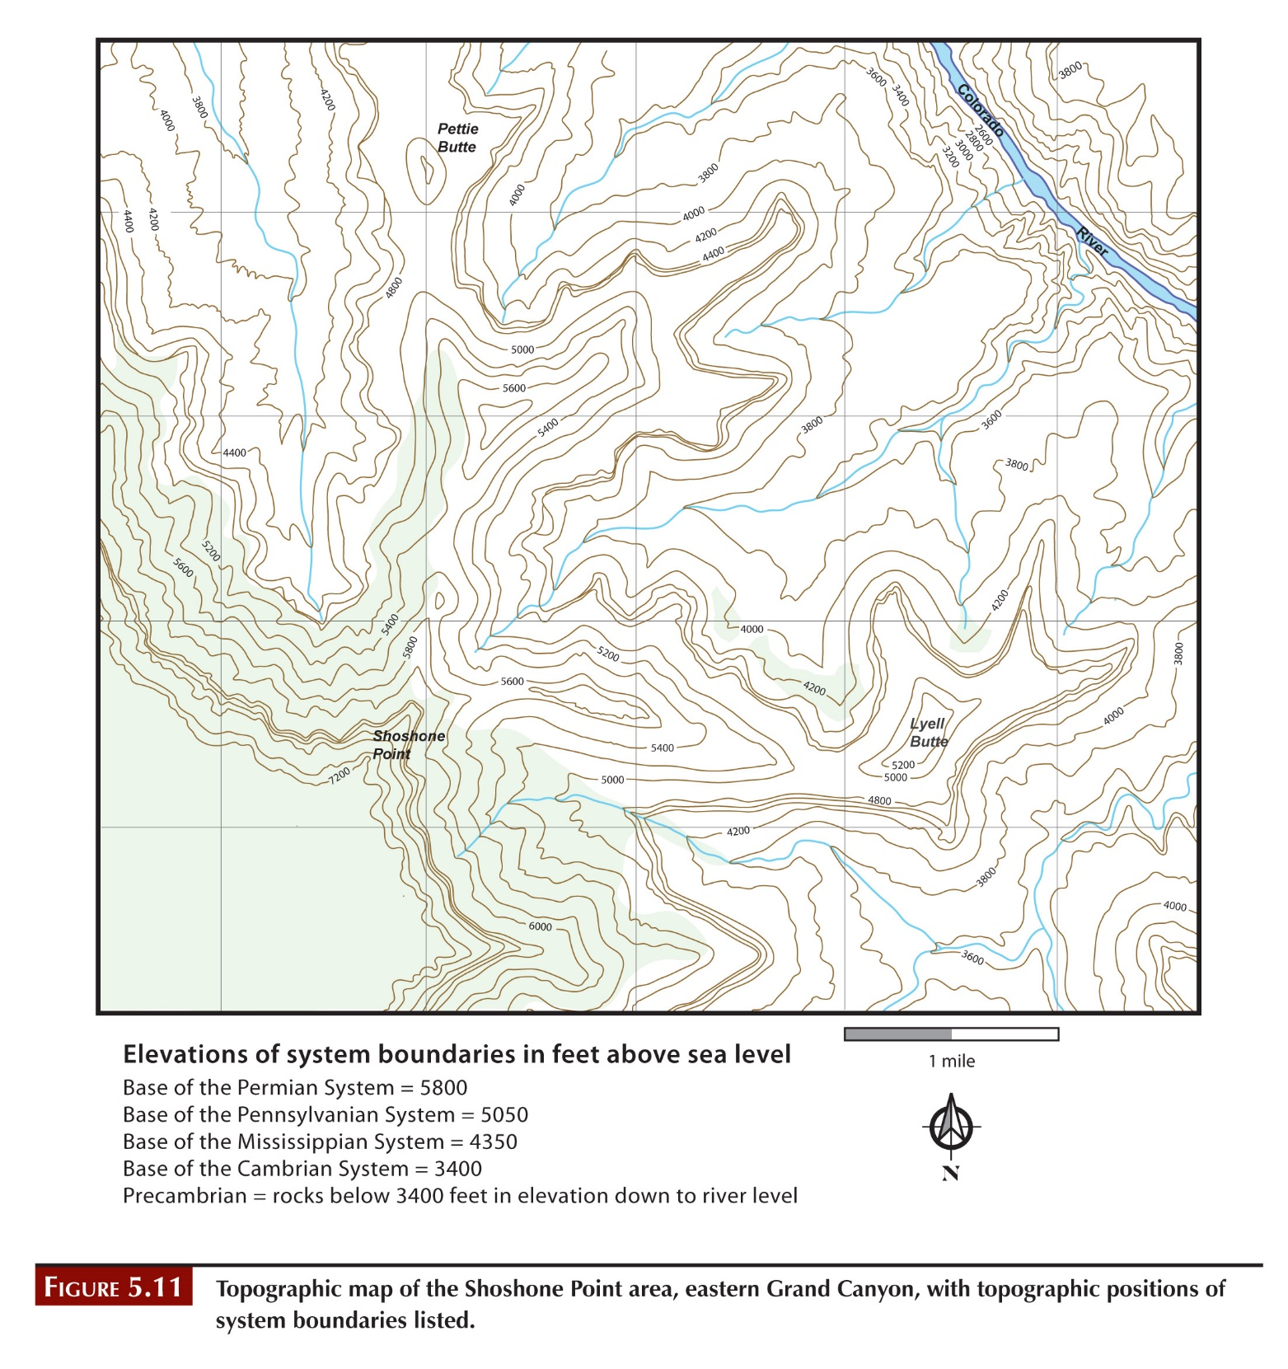

**Answer this question: How does this map compare to the geological map you drew in Part B. Are they similar or different? Do you expect this? Explain in terms of concepts of stratigraphy.**

# **Exercise 5 – Part F**

**Follow the directions on page 76 to complete the table below. The first one has been done as an example.**

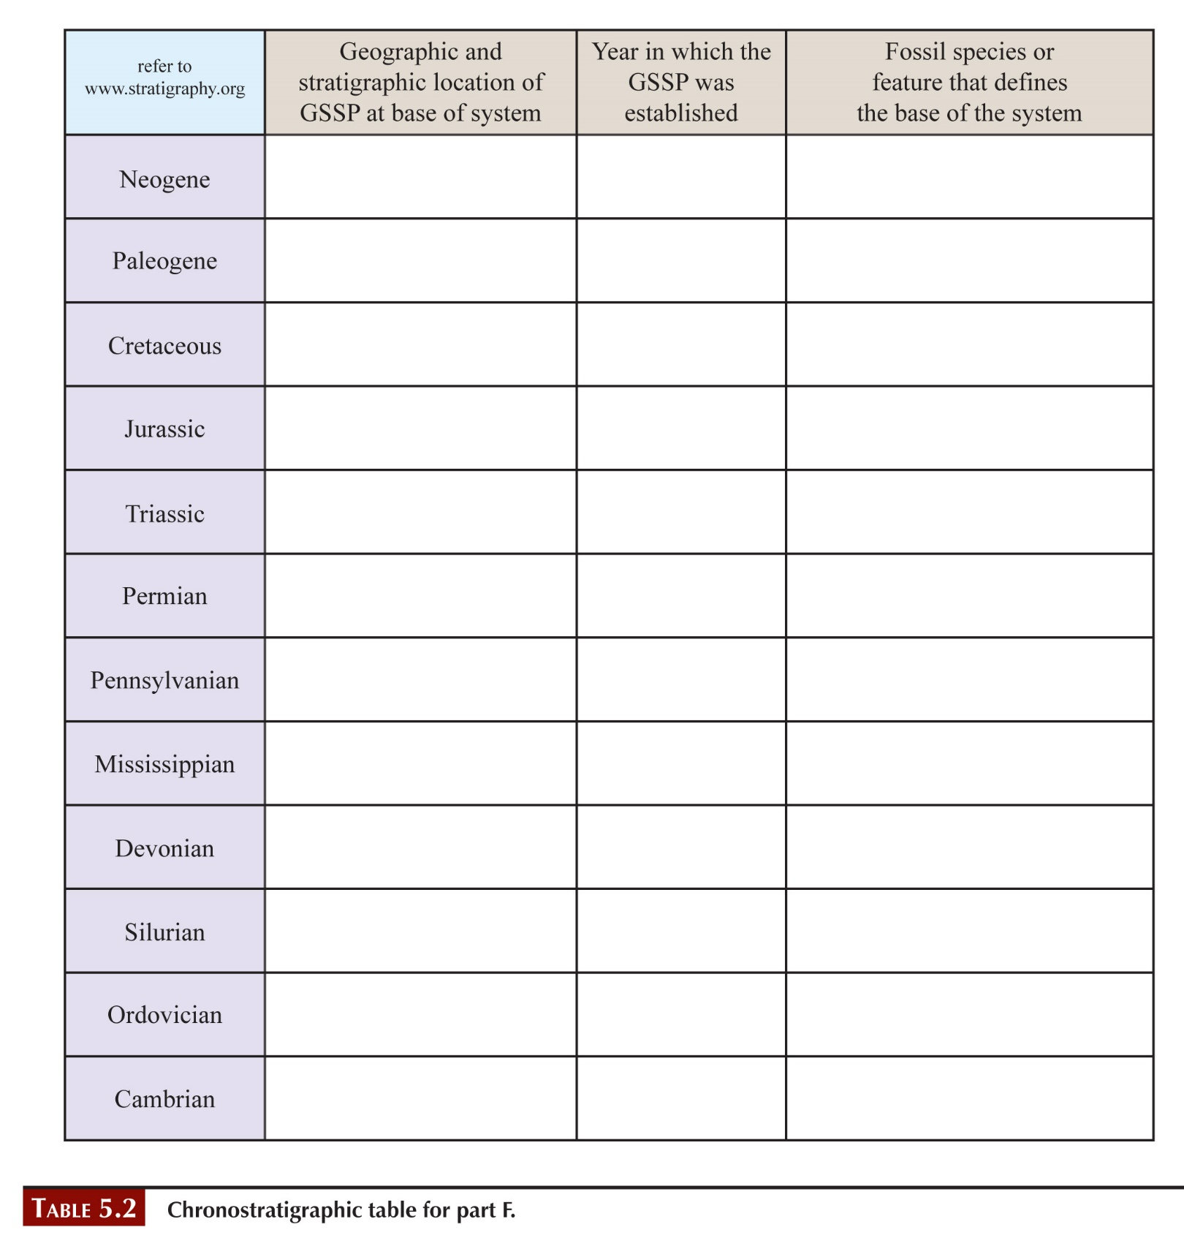

Lemme-Carrosio Section, Allessandria Province, Italy

1996

Magnetism, planktonic foramifera, calcareous nannosfossil, oxygen isotope event

# Exercise 6 – Part A

**Following the directions on page 81, question 1 to correlate the 4 stratigraphic columns below.**

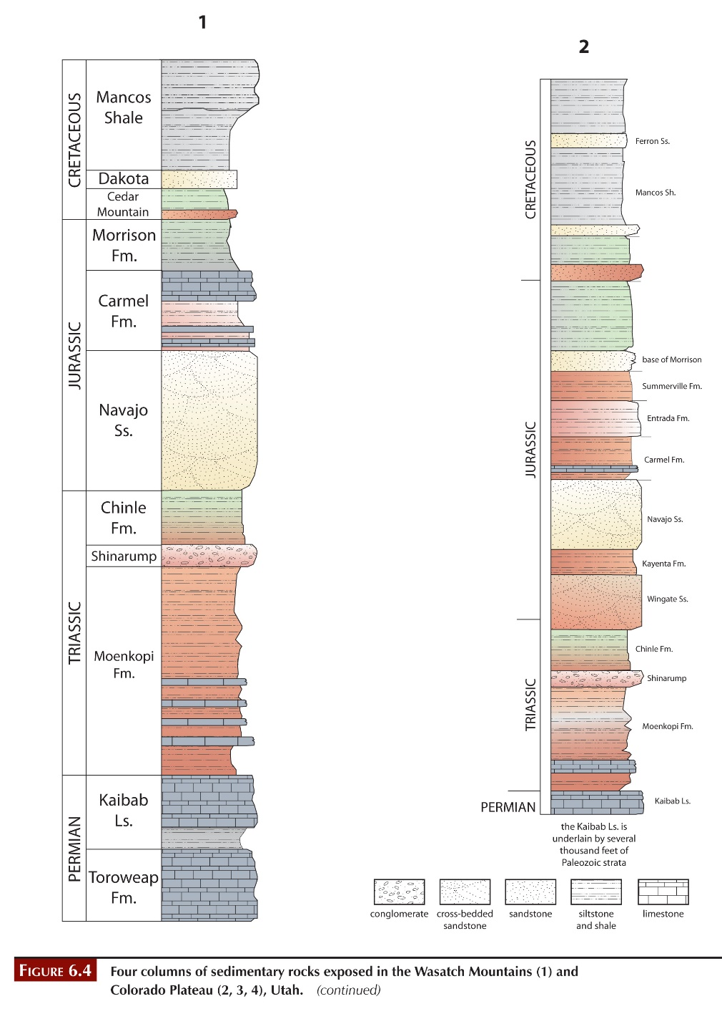

**Then, answer the questions on page 87 below.**

**2. Follow the directions for this question to fill in the table below.**

|  |  |  |
| --- | --- | --- |
| **Stratigraphic column** | **Name / Rock Type below Chinle Formation** | **Age** |
| **1** |  |  |
| **2** |  |  |
| **3** |  |  |
| **4** |  |  |

**3.**

**4.**

**5. a.**

**5. b.**

**5. c.**

# **Lab 4 Reflection**

**In your own words, describe the goals of lithostratigraphy, biostratigraphy, and chronostratigraphy.**

**What was an “ah-ha” moment you had during this lab? This is a time when something suddenly made more sense with additional knowledge.**